Dosimetry Service Assessment and Exposure History Form
RS-03 Memorial Hermann Hospital (Rev 01/2026) The University of Texas Health Science Center at Houston Radiation Safety Program, EHS
Email: radsafe@uth.tmc.edu Phone: (713) 500-5840
Series: Date: Part Number: Account:

Office Use Only

Full Name:

Please print clearly
Last First Middle
Maiden

Name on Badge:
Date of Birth: Gender:
Female
Male

The University of Texas Health Science at Houston (UTHealth) is requesting this information, which will be shared with a third-party dosimetry vendor, for the sole purpose of radiation dosimetry services.
Title: Department: Office Phone: Mobile Phone:

Classification:
Faculty
Fellow
Resident
Other:

Cardiology Cath Lab Faculty (CFX) (located at HVI, 2nd floor) Cardiology Cath Lab Fellow (CFL) (located at HVI, 2nd floor) Pediatric Cardiology (XCP) (Office at Hermann Towers, 11th floor) Cardiovascular Surgery (CVS) (located at HVI, 7th floor) Neurology (DNE/OR) (located at Jones Pavilion, 2nd floor) Anesthesiology (ANE) (located at HVI, 7th floor)
LBJ - Diagnostic Faculty (located at Lyndon B. Johnson Hospital)
Surgery (SUR) (located at MH Pavilion 2) EP Students (EPS)
UTPhysics Radiation Safety (UTR)
Diagnostic Radiology Faculty Badge Coordinator: Diagnostic Radiology Fellow Badge Coordinator: Diagnostic Radiology Resident Graduation Year:
Other (describe radiation use): Have you previously worn a radiation monitor at UTHealth? Yes No If Yes, when? Within this calendar year, have you been exposed to occupational radiation elsewhere? Yes No
If YES, then you must provide the exposure you received for this calendar year and describe that activity.
Your effective dose working as a has been mRem (a blank means that your exposure was minimal.)

Dosimetry Agreement
Please sign the dosimetry service agreement below. For guidance, refer to the follow page.
The information I provided is accurate. I have read this form. I agree to properly use my radiation monitor. I have read the Policies and Procedures related to my work with radiation and I agree to abide by them. I will notify the Radiation Safety Officer of any occupational exposure I receive that is not recorded on my assigned personal radiation monitoring device.

Signature: Date:

Return the completed form to: Radiation Safety Program, 6431 Fannin St., CYF G102, Houston, TX 77030 Or email to: radsafe@uth.tmc.edu
Questions? Call Radiation Safety at (713) 500-5840

Dosimetry Service Assessment and Exposure History Form RS-03 Memorial Hermann Hospital
The University of Texas Health Science Center at Houston
Radiation Safety Program Email: radsafe@uth.tmc.edu Phone: (713) 500-5840

Radiation Monitor Usage
- Personnel assigned radiation monitors are required to be worn while on duty.
- The radiation monitor issued to you must not be loaned to another individual for any reason. Likewise, you may not wear a radiation monitor assigned to anyone else.
- Radiation monitors are for use occupational use, such as at Memorial Hermann Hospital, affiliated clinics, and any other clinic or hospital associated with your normal employment at Memorial Hermann TMC Campus.
- In order to implement special precautions, pregnant employees must notify the Radiation Safety Program in writing that they are pregnant and indicate the estimated date of conception.
- Radiation monitors must be exchanged promptly.
- Wear your whole-body radiation monitor on the upper body unless performing procedures that require a lead apron, in which case the monitor must be worn outside the lead apron at the collar.
- Wear all other monitors (hand, fetal, other special monitors) as instructed by the RSO or RSO’s designee.
- Do not wear the monitor if you are a patient undergoing x-rays or nuclear medicine studies.
- When you are not on duty, your monitor must be kept in your department’s designated storage location or in a suitable personal area away from other sources of radiation.
- The Radiation Safety Officer is required by State Regulations to limit the radiation dose you receive while working at Memorial Hermann TMC Campus to assure that your total annual occupational dose does not exceed 5000 mrem in any calendar year. If you are employed at any other facility where you are monitored for radiation exposure, you must report your radiation dose to the Radiation Safety Officer promptly so that your total accrued radiation dose can be accurately maintained.
- You must read and agree to abide by the Policies and Safety Procedures relevant to your radiation exposure.

Fundamental Radiation Safety Rules
- Perform your duties as usual and do not compromise patient care
- Maintain your distance from the radiation source (patient, machine, or radioactive material) to a maximum consistent with performance of responsibilities.
- Do not spend more time in your duties than necessary, when appropriate remove yourself from the area or station yourself behind protective shields (radiation barrier).
- When not positioned behind a radiation barrier, wear a lead apron when assisting in procedures involving x-ray radiation.
- Always wear your personal radiation monitoring device(s) in the proper location while on duty.
- Follow instructions by the Radiation Safety Officer or the RSO’s designee.
- Notify the Radiation Safety Officer of any situation that you think might lead to or is causing an unnecessary exposure to radiation.
Checking Your Personal Dosimetry Readings

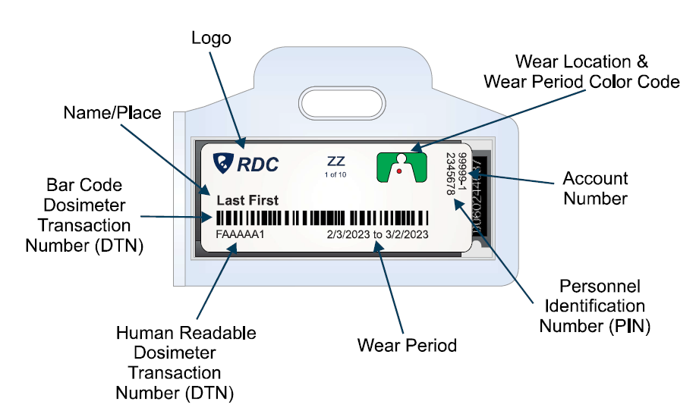
To view your radiation dose readings:
- Go to https://radetco.com/
- Click Dose Check on the top right corner
- In the Badge Number box enter the Human Readable Dosimeter Transaction Number
- In the Personal Identifier enter the Personal Identification Number
- Click Check

